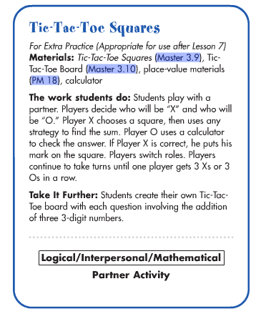

Tic-Tac-Toe Board
Master 3.10
TIC | TAC | TOE
836 + 129 | 456 + 365 | 321 + 383
625 + 345 | 234 + 432 | 459 + 222
535 + 449 | 734 + 137 | 823 + 129

